Work Instruction for Maintenance of Dedustings

1. PURPOSE: Safe Maintenance of De dusting system equipment for Optimum performance
2. SCOPE: Sinter Plant
3. RESPONSIBILITY AND AUTHORITY: Engineer In charge and workmen on the job

4. IDENTIFIED HAZARDS: No major critical hazards . hand injury while checking sensor or handling during installing or removing from equipment

5. SIGNIFICANT ASPECTS

Dust Generation Resource Depletion

Scrap generation Air pollution, Resource depletion
Hazards Identified
Mechanical hazard
- Inhaling of dust.
- Fall of material & person.
- Accident due to improper shutdown.
- Failure of sling, chain pulley block, improper hooks welding.
- Entanglement of a person.
- Use of improper Tools.
Electrical hazard
Electrical shock from welding & open circuit of pulsing valve.

Mandatory instruction:
- Take permission from the shift Superintendent / in charge and electrical shutdown of respective equipment
WORK NO 1: Replacement of Screw Conveyor Cover Seal
- Obtain the shutdown clearance from Electrical Department for related RAV & screw conveyor.
- Make sure the sliding gate of the related hoppers are in closed condition
- Open the top cover bolts and cover and remove damaged seals.
- Apply sealant (Anabond / Holdtite) seal/gasket and fix the cover properly
- Fix all bolts in cover and tighten fully with spanner.
- While handling sealant, the concerned workmen should avoid contact with skin and eyes. Also, excess sealant should be wiped off.
- In case sealant contact with skin or eyes, immediately wash the affected part of the body. Seek medical attention immediately.
- Damaged/worn-out seals to be disposed off in waste bin.
- Normalize shut down and take trial. Open the slide gate.
- Hand over to operation dept.

WORK NO 2: Replacement of RAV Gland packings
- Obtain the shutdown clearance from Electrical Department for the related RAV & screw conveyor.
- Close the sliding gate and start the screw conveyor and RAV to clear the material.
- Loosen the gland bolts of stuffing box packing ring and remove the gland packings.
- Remove all the old packing from the gland housing with the help of pointed rod.
- Reinstall new packing rings with proper lubrication.
- Reinstall the stuffing box ring and gradually tighten the gland bolts.
- Release electrical shut down and take trial. If there is leakage from gland re-work on seal and make it leak proof by tightening the gland clamp bolts.
- Hand over to operation.
- Worn-out packing to be disposed off in hazardous waste bin

Work No 3: Removal & fixing of RAV for jam for cleaning

- Obtain the shutdown clearance from Electrical Department for required RAV & related screw conveyor.
- Ensure sliding gate valve (manual) above RAV is in closed condition.
- Ensure that electrical connection to the RAV motor is removed.
- Remove the RAV motor and then RAV gearbox.

- Remove the bolts of RAV to facilitate RAV flange rotation (keep one bolt loosened for rotation of valve)
- Check for any obstruction in the RAV vanes (usually welding rods, angles or channels do come and cause jamming of RAV).
- Clean valve & check if is rotating by hand or not (rotate motor fan to check freeness). – Resp: operation dept
- Take RAV in position.
- Fix proper sealing /gasket.
- Fix all bolts & tightened it fully.
- Release electrical shut down and take trial. Monitor current.
- Hand over to operation dept and inform to normalize all valve positions.
Do not start work unless closing gate valve above RAV

Work No 4: Replacement of Screw conveyor bearing (DE side)

- Obtain the shutdown clearance for respective screw conveyer from Electrical Department.
- Clean work area
- Remove coupling guard.
- Decouple the motor
- Remove coupling half for replacing drive end bearing
- Open bearing block by removing the bolts
- Remove bearing locking circlip
- Clean surface area & check shaft for wear out.
- Replace bearing with new one. Put the circlip back in position.
- Fix bearing block with new grease.
- Fix coupling & motor assembly in case of drive side bearing.
- Ensure coupling guard is put back and bolted
- Check for completion in all respect.
- Clear electrical shut down.
- Hand over for operation.

Work No 5 : Replacement of Pneumatic cylinder

- This can be done by isolating individual chamber
- Close & Disconnect airline connection. For particular chamber to be attended
- Depressurized the system disconnect solenoid valve.
- Remove end connection.
- Remove cylinder mounting.
- Replace cylinder by new /repaired cylinder.
- Fix cylinder mounting and align
- Resume all air line connections one by one
- Charge the pneumatic system by opening main valve.
- Check for completion in all respect.
- Normalize isolated chamber

- Hand over for operation dept

Work No 6 : Replacement / inspection of Bags
- Take Work Permit from the shift Superintendent / in charge after following all the necessary safety points indicated in the work permit
- Bags can be checked during running of fan.
- Top chamber of which the bags to be checked must be isolated.
- Isolation of chamber can be done by putting the knob of Directional control valve in upward position by putting knob upward, cylinder extracts out and closes the outlet chamber.
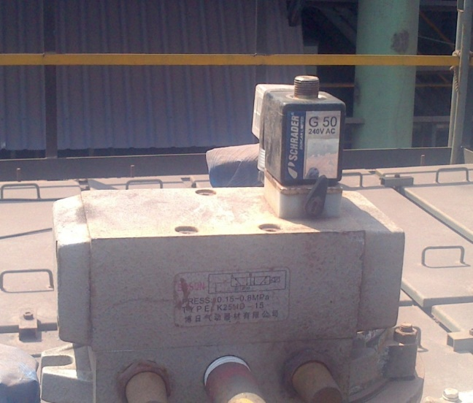
Knob in upward position

- Cylinder bottom pneumatic tube (blue colour pipe) to be removed so that there will be no air supply to the cylinder & it will be pneumatically isolated.
- Close the inlet manual valve of the header (Purging tank) of the isolated chamber.

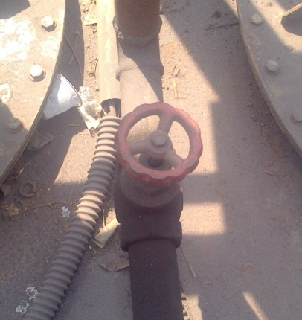

- Open the drain valve of the header (purging tank.
- Now remove the top door of the isolated chamber.
- Persons working should wear dust mask, goggles, hand gloves and safety belt.
- Then open the clamps of purging pipe and remove the same.
- Remove the cage and bag simultaneously
- Check for damaged bags and replace if damaged.
- If the bag falls inside the bunker that should be removed outside by given platform through opening manhole and close the same after removing of bags.
- Once the bags inspection is completed close the top door after positioning the purging pipes.
- Close the drain valve and open the inlet valve of the header

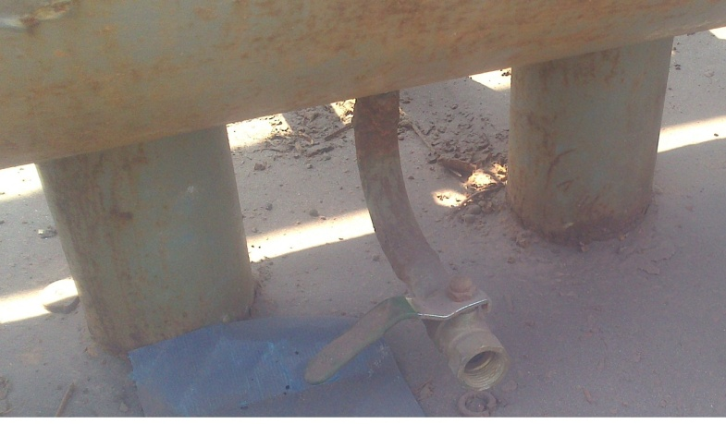
Drain valve of header in close position.

16. Fix the Pneumatic tube of cylinder and put the knob back inSide position
17. Clear all unwanted material from site and release the work permit and handover for operation.

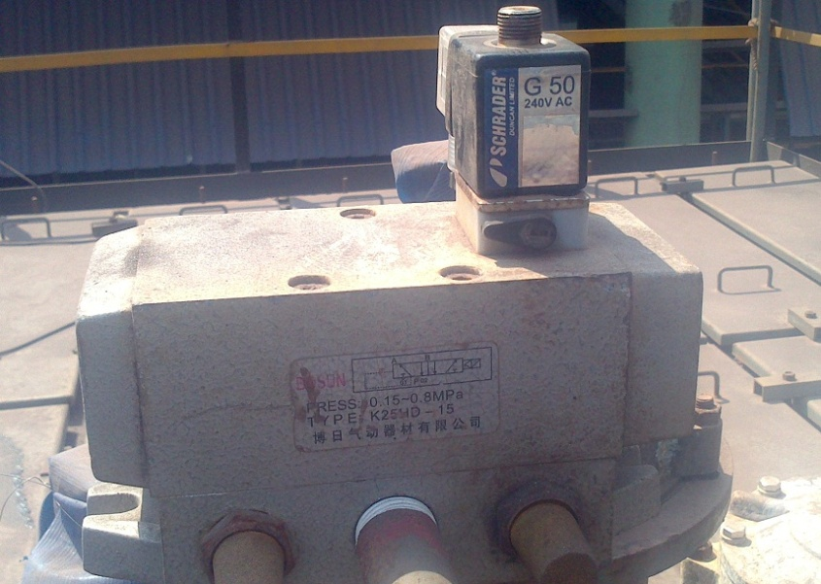
Knob in side position

Work No 7: Replacement of Screw conveyor bearing (NDE side)

- Obtain the shutdown clearance for respective screw conveyer from Electrical Department.
- Clean work area.
- Open the Plummer block guard,
- Open bearing block by removing the bolts
- Remove bearing locking circlip
- Remove the bearing with the help of puller.
- Clean surface area the shaft & check for wear out.
- Replace bearing with new one. Put the circlip back in position.
- Fix bearing block with new grease.
- Clear electrical shut down.
- Hand over for operation after taking trial.

Work No 8 :Replacement of suction duct (During Shutdown)
- The above job to be attended during shutdown.
- Obtain the shutdown clearance for respective Fan from Electrical Department.

- Scaffolding/Platform arrangement to be made where the duct to be replaced.
- Wear safety belt and other PPE s without fail. Follow the procedure SP 44 and SP 103.
- Position the crane/Hydra, Barricade the area with safety caution tape
- Put the certified belt sling for lifting the duct pipe and take slight load.
- Gas cut the damaged duct pipe and lowers it slowly on ground.
- Lift the correct size pipe and insert it properly between the ducts, please see that directions for the crane operator by single responsible person to avoid any miscommunication.
- Suction line to inspect and cleaning if required.
- Fix the new pipe by welding.
- Clear the shutdown, Take trial, if found ok then handover it to operation.

Work No 9 :Replacement of suction duct (During Running)
1The above job to be attended during running.
2Obtain the work permits from shift super intendent.
3. Scaffolding/Platform arrangement to be made where the duct to be replaced.
- Wear safety belt and other PPE s without fail. Follow the procedure SP 44 and SP 103.
- Position the crane/Hydra, Barricade the area with safety caution tape
- Put the certified belt sling for lifting the duct pipe and take slight load.
- Isolate the respective suction duct by cutting a slot and inserting a dummy plate towards the suction side.
- After that open the damper fully.

- Lift the correct size pipe and insert it properly between the duct, please see that directions for the crane operator by single responsible person to avoid any miscommunication.
- Fix the new pipe by welding.
- Close the respective fan damper and remove the dummy plate which was put for isolating the duct earlier.
- Same size pipe strip to be tag welded above the slot.
- After that open the damper of fan asusual.
- Weld the above pipe strip fully during running of the fan.
- Check the all welding joints.
- Clear the Work permit.

Work No 10 : Replacement of Humidifier assembly.

- Take permission from operation department
- Obtain the shutdown clearance for respective Humidifier, Vibrator & Silo RAV from Electrical Department. (Disconnect all the power cable from mo\tor side )
- Check and Clean work area .(operation department )
- Remove coupling guard.
- Close the water line (top) valve and Disconnect the hose from humidifier.
- Cut all the base plate of humidifier. remove all the bolts from RAV top flange. .
- Barricade the area. .
- Remove front side hen railing. .
- Remove full humidifier assembly with RAV by the help of hydra.
- Fix beck the humidifier assembly with RAV and vibrator by the help of hydra. .
- Fix beck the front side hen railing.
- Fix all the bolts of RAV to flange and weld all the humidifier base plate
- Reconnect the hose to humidifier and open the water line main (top) valve.
- Fix all the coupling guard. .
- Clear all the electrical shutdown.
- Take trial and conform the direction of humidifier if it is ok then handover to operation department. .

Work No 11 Replacement of Humidifier spiral .

- Take permission from operation department.
- Obtain the shutdown clearance for respective Humidifier, Vibrator & Silo RAV from Electrical Department.
- Remove coupling guard.
- Remove V belt & pulley .
- Open bearing block by removing the bolts *(DE & NDE ).
- Remove bearing *(DE & NDE ).
- Remove Damage spiral of Humidifier From NDE Side.
- Insert new spiral of Humidifier From NDE Side.
- Insert all the flanges and seals .
- Fix both the bearing *(DE & NDE ).
- Fix both sides Plummer block with bolt *(DE & NDE ).
- Check free rotation of spiral.
- Fix Drive pulley and V belt & align the motor properly.
- Fix all the coupling guard .
- Clear all the electrical shutdown.
- Take trial and conform the direction of humidifier if it is ok then handover to operation department

Work No 12 Replacement of Humidifier DE Bearing .
- Take permission from operation department.
- Obtain the shutdown clearance for respective Humidifier & Vibrator from Electrical Department.
- Remove coupling guard.
- Remove V belt & pulley .
- Open bearing block by removing the bolts.
- Remove bearing locking circlip
- Clean surface area & check shaft for wear out.
- Replace bearing with new one. Put the circlip back in position.
- Fix bearing block with new grease.
- Fix V belt & pulley
- Ensure coupling guard is put back and bolted.
- Check for completion in all respect.
- Clear electrical shut down.
- Take trial and conform the direction of humidifier if it is ok then handover to operation department .

Work No 13 Replacement of Humidifier NDE Bearing .

- Take permission from operation department.
- Obtain the shutdown clearance for respective Humidifier & Vibrator from Electrical Department.
- Open bearing block by removing the bolts.
- Remove bearing locking circlip
- Clean surface area & check shaft for wear out.
- Replace bearing with new one. Put the circlip back in position.
- Fix bearing block with new grease.
- Check for completion in all respect.
- Clear electrical shut down.
- Take trial and conform the direction of humidifier if it is ok then handover to operation department .

Work No 14 Replacement of bucket elevator bucket & chain .

- Take permission from operation department.
- Confirm for the electrical isolation of the bucket elevator by taking electrical shutdown.
- Isolate the feeding material by taking the Screw conveyor shutdown.
- Open the bottom door of tail pulley.
- Inspect each of the buckets by rotating the conveyor with hand.
- Position the damage part in front of bottom door.
- Loose the tensioning device and lock the bucket conveyor
- Lock the both side chain by rope (wire /nylon).
- Replace the damage bucket & chain with new one .
- Unlock the chain and tight it with tensioning arrangement.
- Close the inspection door.
- Clear electrical shut down to take no load trial.
- Check function in running condition
- Check for any abnormal sounds or vibrations
- If found satisfactory give clearance for operation.
Work No 15 Replacement of bucket elevator Gearbox .

- Take permission from operation department.
- Confirm for the electrical isolation of the by taking electrical shutdown.
- Decouple the gearbox from the drive unit.
- Unscrew and remove all the foundation bolts.
- Hold the gearbox properly with sling and chain block arrangement.
- Lift the gearbox vertically with all shims in position.
- Remove the gearbox and place it in a safe position.
- Clean the base of gearbox removing seams one by one and replace seams in their original position.
- Place new gearbox with the help of sling and chain block arrangement.
- First align the gearbox with the pulley.
- Fully tight the gearbox foundation bolts with lock nut, loose jack bolts.
- Complete the alignment of gearbox and motor.
- Give clearance for motors power supply cable.
- Clear electrical shut down and take no load trail.
- If found satisfactory, surrender work permit and hand over the equipment for operation.

Work No 16 Replacement of bucket elevator Drum bearing.

- Take permission from operation department.
- Confirm for the electrical isolation of the bucket elevator by taking electrical shutdown.
- Check for any abnormal sound or vibrations in the bearing before going for this step.
- If abnormal sound/vibrations observed arrange for the dismantling of bearing.
- Loose the tensioning device and lock the bucket conveyor.
- Remove the end cover of the bearing and then oil seal/sealing with care as it is delicate component.
- Check for any abrasive marks on the bearing balls or inner race.
- If marks are there on the bearing, it shows bearing got damaged and needs replacement.
- Fix new bearing, put oil seal/sealing, and then end cover.
- Unlock the chain and tight it with tensioning arrangement.
- Clear electrical shut down and take no load trail.
- If found satisfactory, hand over the equipment for operation.

Work No 17 Replacement of bucket elevator Tail Drum .
- Take permission from operation department.
- Empty the buckets.\
- Confirm for the electrical isolation of the bucket elevator/Screw conveyor by taking electrical shutdown.
- Remove tail pulley bottom door at both sides.
- Loose the take up arrangement (tensioning arrangement).
- Remove guide bar.
- Remove holding arrangement.
- Remove tail pulley with two chain blocks.
- Place new pulley with complete assembly.
- Remove the chain block and close the door.
- Tight it with tensioning arrangement.
- Clear electrical shut down and take no load trail.
- If found satisfactory and hand over the equipment for operation.

Work No 18 Replacement of bucket elevator Head Drum .
- Take permission from operation department.
- Empty the buckets.\
- Confirm for the electrical isolation of the bucket elevator/Screw conveyor by taking electrical shutdown.
- Loose the take up arrangement (tensioning arrangement).
- Open the top hood cover. .
- Lock the both side chain by the help of two chain block (cap.-3ton) / any wire rop clamping arrangement.
- Cut the chain from middle (of lifted part)
- Remove Head pulley by the help of crane
- Place new pulley with complete assembly by the help of crane.
- First align the pulley with the gearbox
- Fully tight the pulley Plummer block foundation bolts with lock nut, loose jack bolts.
- Re-joined the chain link
- Unlock the chain and tight it with tensioning arrangement.
- Close the top hood cover.
- Check for completion in all respect.
- Clear electrical shut down and take no load trail.
- If found satisfactory and hand over the equipment for operation

Work No 19 Bucket Elevator Inspection
- Take permission from operation department.
- Empty the buckets.
- Confirm for the electrical isolation of the bucket elevator by taking electrical shutdown.
- Open the bottom door of tail pulley.
- Inspect each of the buckets by rotating the conveyor with hand.
- Check the condition of the buckets.
- Check for any rubbing of washer/bolts with the bucket.
- If bolts found loose, fasten them.
- Close the inspection door.
- Clear electrical shut down to take no load trial.
- Check function in running condition
- Check for any abnormal sounds or vibrations
- If found satisfactory give clearance for operation.

Work No 20 : Inspection & patching of bunker partition plate .
- Procedure (This is a confined space and necessary control measures and deliberations must be in place before taking up this job) :
- Take work permit from the shift Superintendent / production in charge and obtain the shutdown clearance from Electrical Department with LOTO.
- Hopper needs to be emptied.
- Check & arrange proper illumination inside the bunker.
- If the temperature inside the bunker is more than 40 deg and dusty, wait till it reaches 40 deg or less so it is safe to go inside.
- During working inside, oxygen readings should be monitored continuously. (Oxygen level should be between 19.5-23%)
- Use 24v handlamp and torch.
- Before entering the bunker, ensure that corresponding screw conveyor preceding and succeeding the bunker is taken shut down.
- In case you are working below belt then
    - Before starting the job, cover belt below with GI sheet or MS plate of required length.
    - Rope ladder & lifeline to be used for entering in bunker.
    - Temporary working platform to be erected if required
- If working at height, barricade the area below.
- Inspect the bunker partition plate and correct if required by cutting welding.
- Once the job is completed, ensure that all scrap generated is shifted from site and the GI sheet or MS plate is removed.
- Clear electrical shut down and take trials in manual mode, wherever possible.
- Hand over the equipment to Production dept.

Amendement Record
Date | Manual Section Ref. & Para | Brief details of Revision | New Rev.

Signature | Signature: | Signature:
Review Date: 21.02.2023 | Review Date: 21.02.2023 | Review Date: 21.02.23

